**“CATTLE INDEMNITY”**

**Abstract:**

Cattles are very important in economical aspects. Many families which live in rural areas depend on these for income. They have been used to obtain food like milk, eggs, meat, etc. Other than the food, we use them even for some basic requirements like wool, silk, labour etc. The population has reached its peak especially in a country like India. The population explosion has led to greater demand for basic requirements such as food, shelter, clothing, etc. To meet the increasing requirements and demands we need to apply a greater effort. One of such efforts to meet the food demand is animal husbandry. Animal husbandry includes cattle farming, poultry farming, fisheries, apiculture, etc. Here we will learn about cattle farming.

If the cattle came out from the fencing. Ultrasonic sensor measures the distance of the cattle. If the cattle is near to the fencing the buzzer will sounds and GMS will send message to the mobile through arduino.

**Introduction:**

Since the time immemorial, animals have been an integral part of our food. They have been used to obtain food like milk, eggs, meat, etc. Other than the food, we use them even for some basic requirements like wool, silk, labour etc. The population has reached its peak especially in a country like India. The population explosion has led to greater demand for basic requirements such as food, shelter, clothing, etc. To meet the increasing requirements and demands we need to apply a greater effort. One of such efforts to meet the food demand is animal husbandry.

Animal husbandry includes cattle farming, poultry farming, fisheries, apiculture, etc. Here we will learn about cattle farming. A large number of people in India being less literate and unskilled depend upon agriculture for their livelihoods. If the cattle came out from the fencing. Ultrasonic sensor measures the distance of the cattle. If the cattle is near to the fencing the buzzer will sounds and GMS will send message to the mobile through arduino.

**Block Diagram:**

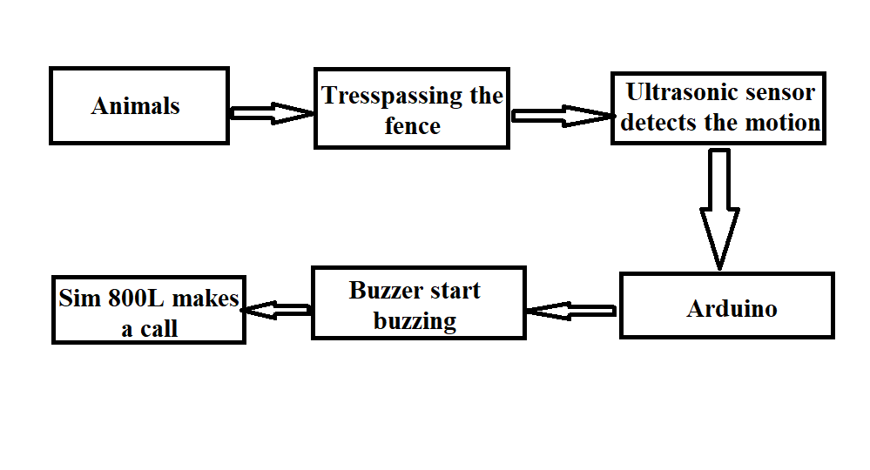**Simulation:**

* + - A type of sensor boundary can be arranged which informs the cattle

Men about his cattle by generating an alarm in his/her mobile when the cattle tries to cross the boundary of the shed.

* + - If the cattlemen doesn’t react for the alarm then the alarm sensor which is at thee shed gets activated.
    - In this ultrasonic sensors and alarm sensors are taken in to action.
    - By the cattlemen gets information to make them alert.

Hence this is also affordable by the small shepherd /cattle rearer.

**Final Product:**

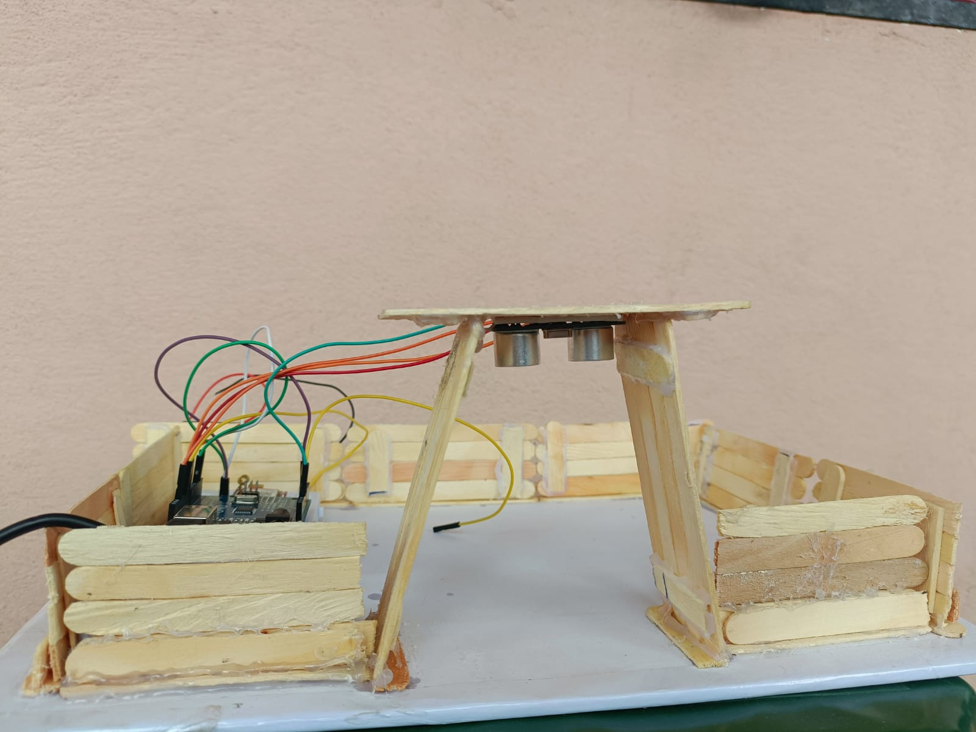

**Conclusion:**

* Cost is lower than other techniques like GPS trackers and high fencing.
* This is not that complicated one so rural people can easily understand how to use it
* Doesn’t required more equipment too.
* If the cattlemen doesn’t react for the alarm then the alarm sensor which is at the shed gets activated. So other person can easily get to know the problem
* User satisfaction (main aim for doing this project), farmers and people like shepherds will be helpful by this equipment.

By We, as a team, just want the shepherds to take advantage by using our equipment. Our equipment also uses multiple technologies in different aspects of it's functioning. We are also thinking to make this project with all quality materials and also with less expenditure.

This project also enables shepherds to help the trade of cattle.